# grep Assignment

**Mandatory:**

1. Use any .c file. Using grep command extract and display
   1. all lines beginning with #include with line numbers

* grep -n ‘^#include’ temp.c
* 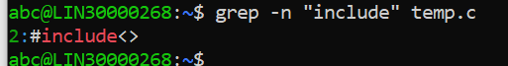
  1. display all lines which do not begin with #include
* grep “^[A-Za-z]” temp.c

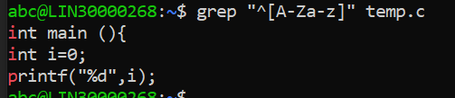

* 1. display the line number of main()
* grep -n “main” temp..c

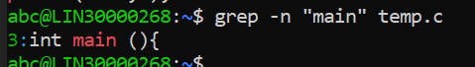

* 1. extract all lines containing characters of opening and closing parathesis {(,))
* grep “[(*){*}]” temp.c

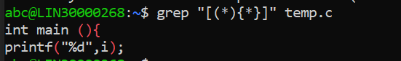

1. Perform the above operations on a set of *.c files

* grep -n ‘^#include’ *.c
* grep “^[A-Za-z]” *.c
* grep -n “main” *.c
* grep “[(*){*}]” *.c